Welcome to
Trinity Lutheran Church
Lutheran Church—Missouri Synod
A Stephen Ministry Congregation

1354 South Otsego Avenue
Gaylord, Michigan 49735
Church Phone: (989) 732-4816

Church Email: secretary@trinitygaylord.com
www.trinitygaylord.com

Office Hours: Monday through Friday 9am – 1pm

OUR PURPOSE
…is to LOVE GOD, LOVE OTHERS, AND SERVE THE WORLD by worshiping the Lord Jesus, bringing our members into Christ-like maturity, and equipping them through Word and Sacrament for their mission and ministry. We go heart to heart into the world with Jesus, sharing His love, caring for one another, praying, and bringing the lost into a relationship with Christ, by the working of the Holy Spirit.

May 8, 2022
Mother’s Day
Fourth Sunday of Easter
Preacher: Rev. Ken Bernthal

ABOUT OUR WORSHIP
We welcome all who gather here today! We are blessed to celebrate together the mercy, grace, and love we have from God through the death and resurrection of our Lord Jesus Christ.

Children: Families with children are very welcome here. Having children in church is important so they can begin to learn about their faith in Jesus, and it’s good for the whole congregation to see. Please feel comfortable keeping “squirmy” kids in the service. This is where they belong, too!

Pew Cards: Guests and Members, please fill out the Guest/Member card located on the back of the pew in front of you and pass it to the end of the aisle. If you forget you can put it in the offering plate on your way out.

If standing is difficult: Please feel free to remain seated during any portion of the service. Please let an Elder or Usher know if you need communion in your pew seat.

About our celebration of Holy Communion: We celebrate the Lord’s Supper in the confession and glad confidence that, as he says, our Lord gives into our mouths not only bread and wine but his very body and blood to eat and to drink for the forgiveness of sins and to strengthen our union with him and with one another. Our Lord invites to his table those who trust his words, repent of all sin, and set aside any refusal to forgive and love as he forgives and loves us, that they may show forth his death until he comes.

Because those who eat and drink our Lord’s body and blood contrary to that which is stated above do so to their great harm, and also because Holy Communion is a confession of the faith which is confessed at this altar. Anyone who is not yet instructed, in doubt, or who hold a confession differing from that of the Lutheran Church—Missouri Synod, and yet desire to receive the sacrament, are asked first to speak with Pastor. Those not communing are still invited to come forward for a blessing from Pastor, and you may indicate this by crossing your arms over your chest.
TTTTTT

GREETING
P Peace be with you.
C And also with you.
T ORDER OF SERVICE T
(The liturgy is from Divine Service Setting four LSB pg. 203ff)

OPENING HYMN
Savior, like a Shepherd Lead Us LSB 711
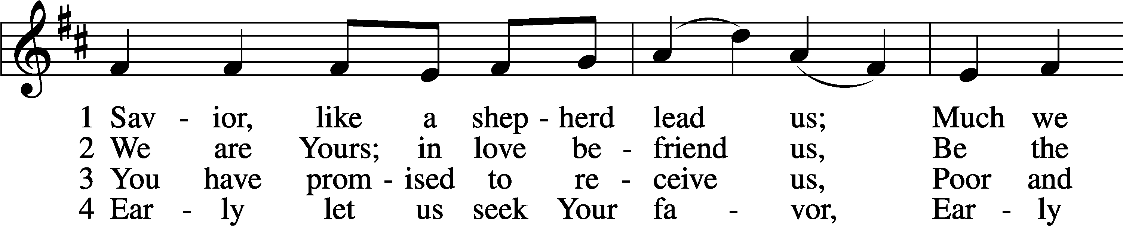
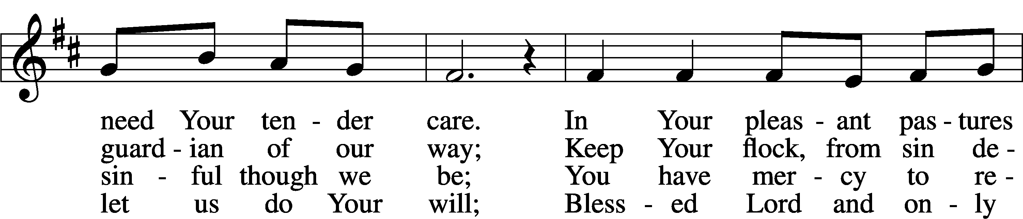
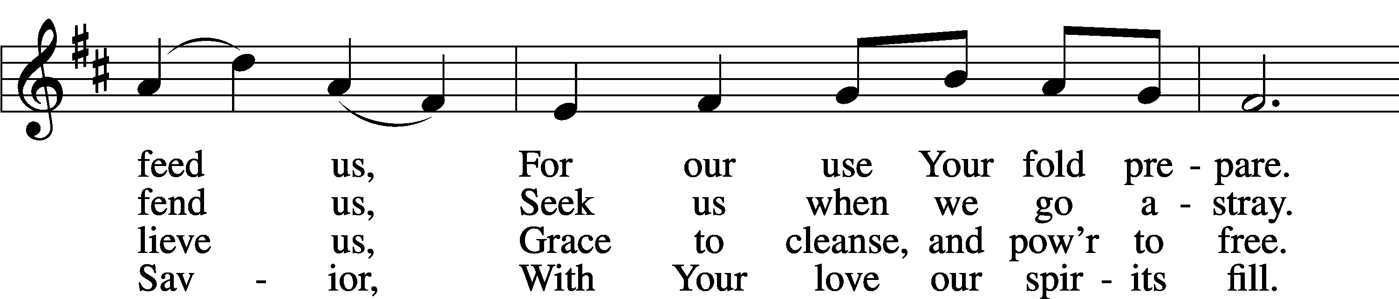
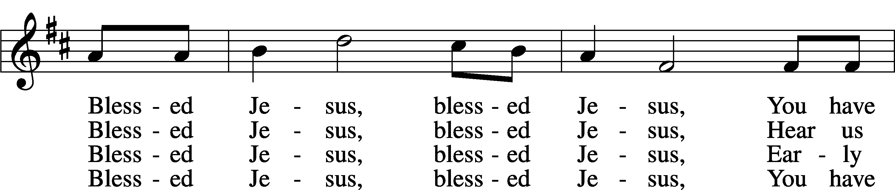
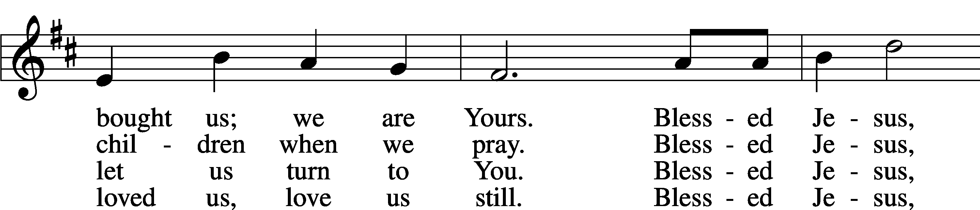
Continued on next page
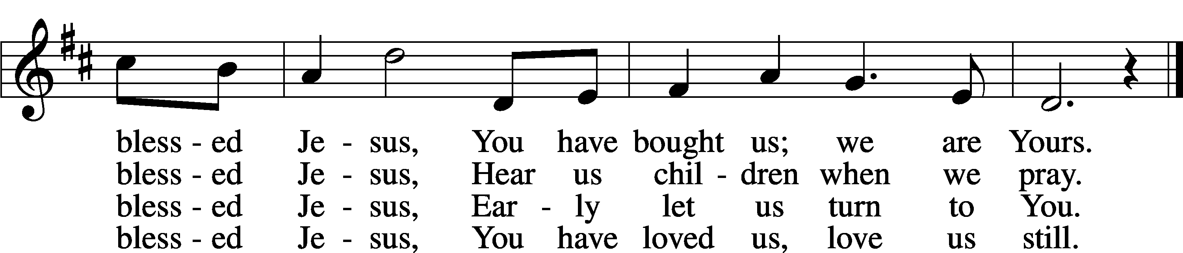
Text: Hymns for the Young, 1836, 4th ed., London, alt.
Tune: William B. Bradbury, 1816–68
Text and tune: Public domain

Please stand as able
CONFESSION and ABSOLUTION
The sign of the cross may be made by all in remembrance of their Baptism.

P In the name of the Father and of the T Son and of the Holy Spirit.
C Amen.
P Our help is in the name of the Lord,
C who made heaven and earth.
P If You, O Lord, kept a record of sins, O Lord, who could stand?
C But with You there is forgiveness; therefore, You are feared.
P Since we are gathered to hear God’s Word, call upon Him in prayer and praise, and receive the body and blood of our Lord Jesus Christ in the fellowship of this altar, let us first consider our unworthiness and confess before God and one another that we have sinned in thought, word, and deed, and that we cannot free ourselves from our sinful condition. Together as His people let us take refuge in the infinite mercy of God, our heavenly Father, seeking His grace for the sake of Christ, and saying: God, be merciful to me, a sinner.
C Almighty God, have mercy upon us, forgive us our sins, and lead us to everlasting life. Amen.
P Almighty God, merciful Father, in Holy Baptism You declared us to be Your children and gathered us into Your one, holy Church, in which You daily and richly forgive us our sins and grant us new life through Your Spirit. Be in our midst, enliven our faith, and graciously receive our prayer and praise; through Your Son, Jesus Christ, our Lord.
C Amen.

SERVICE OF THE WORD

INTROIT Psalm 78:70–72; 79:13; antiphon: John 10:14, 15b
P I am the good shepherd.
I know my own and my own know me, and I lay down my life for the sheep.
C He chose David his servant and took him from the sheepfolds;
from following the nursing ewes he brought him to shepherd Jacob his people, Israel his inheritance.
P With upright heart he shepherded them
and guided them with his skillful hand.
C But we your people, the sheep of your pasture, will give thanks to you forever;
from generation to generation we will recount your praise.
ALL Glory be to the Father and to the Son
and to the Holy Spirit;
as it was in the beginning,
is now, and will be forever. Amen
P I am the good shepherd.
I know my own and my own know me, and I lay down my life for the sheep.

KYRIE LSB 204
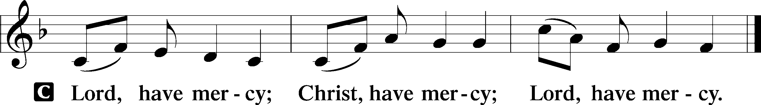

GLORIA IN EXCELSIS LSB 204
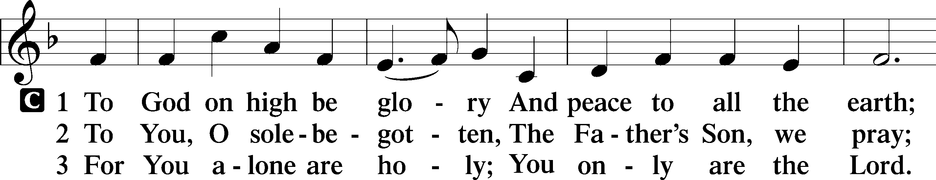
Continued on next page
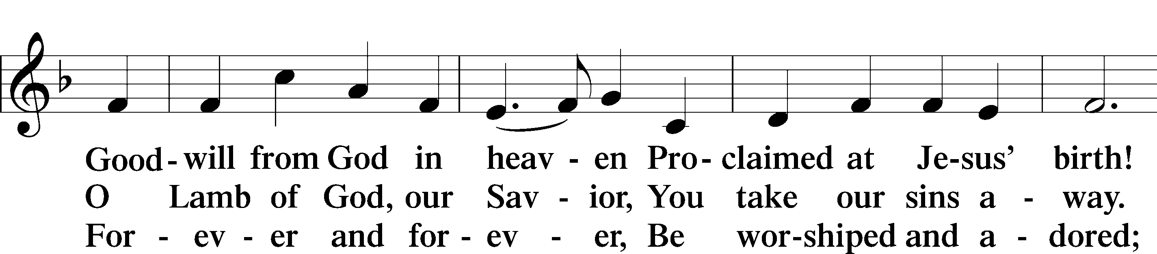
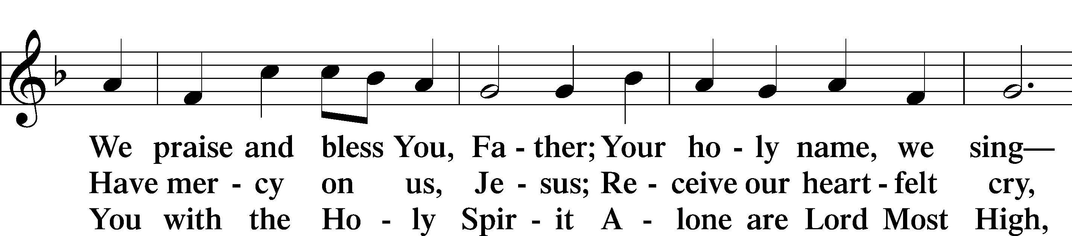
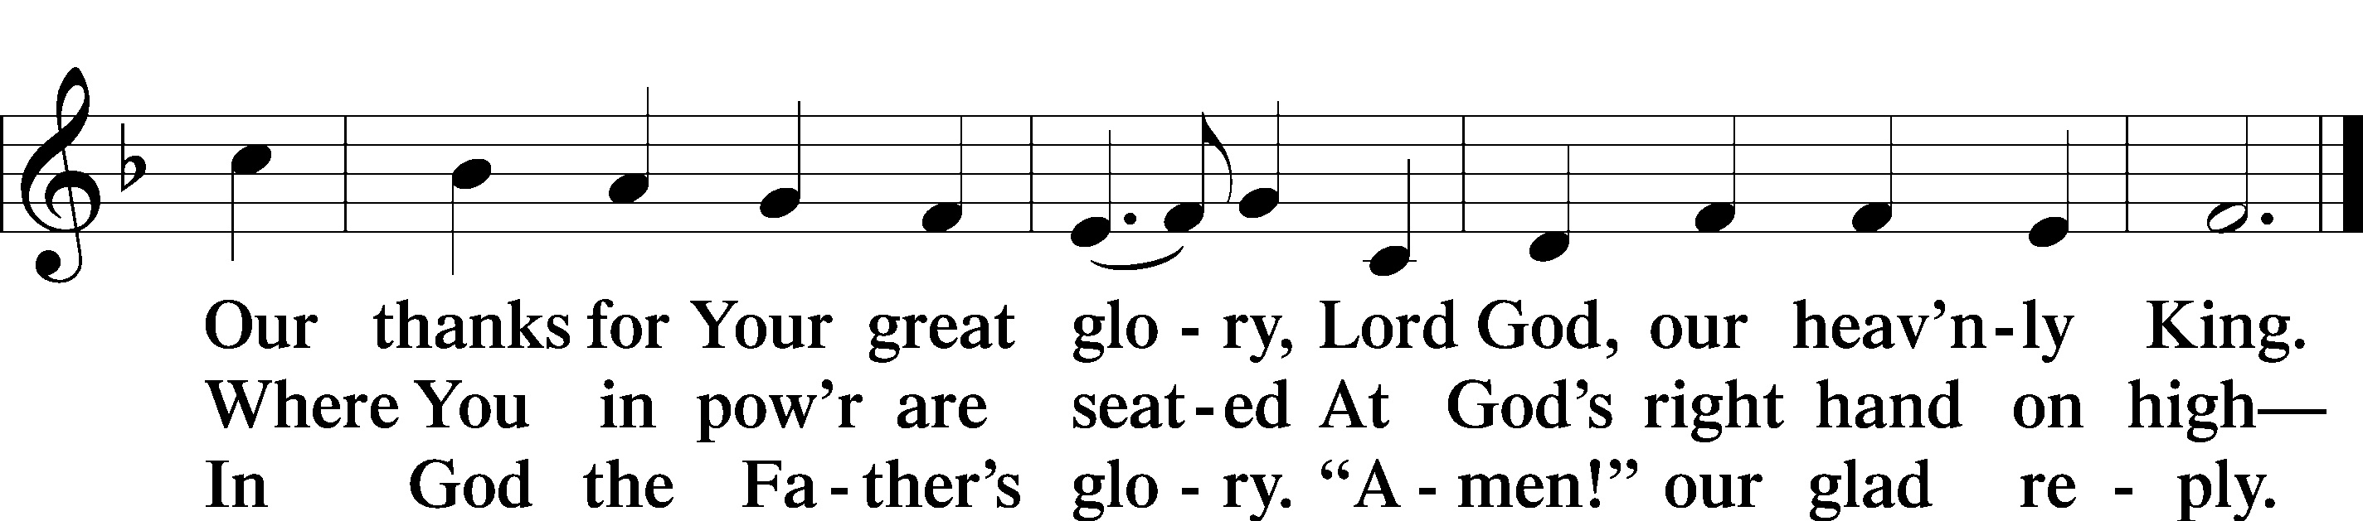
Text: Stephen P. Starke

SALUTATION AND COLLECT OF THE DAY

P The Lord be with you.
C And also with you.

P Let us pray.
Almighty God, merciful Father, since You have wakened from death the Shepherd of Your sheep, grant us Your Holy Spirit that when we hear the voice of our Shepherd we may know Him who calls us each by name and follow where He leads; through the same Jesus Christ, Your Son, our Lord, who lives and reigns with You and the Holy Spirit, one God, now and forever.
C Amen.

Please be seated

FIRST READING Acts 20:17–35
¹⁷Now from Miletus [Paul] sent to Ephesus and called the elders of the church to come to him. ¹⁸And when they came to him, he said to them:
“You yourselves know how I lived among you the whole time from the first day that I set foot in Asia, ¹⁹serving the Lord with all humility and with tears and with trials that happened to me through the plots of the Jews; ²⁰how I did not shrink from declaring to you anything that was profitable, and teaching you in public and from house to house, ²¹testifying both to Jews and to Greeks of repentance toward God and of faith in our Lord Jesus Christ. ²²And now, behold, I am going to Jerusalem, constrained by the Spirit, not knowing what will happen to me there, ²³except that the Holy Spirit testifies to me in every city that imprisonment and afflictions await me. ²⁴But I do not account my life of any value nor as precious to myself, if only I may finish my course and the ministry that I received from the Lord Jesus, to testify to the gospel of the grace of God. ²⁵And now, behold, I know that none of you among whom I have gone about proclaiming the kingdom will see my face again. ²⁶Therefore I testify to you this day that I am innocent of the blood of all of you, ²⁷for I did not shrink from declaring to you the whole counsel of God. ²⁸Pay careful attention to yourselves and to all the flock, in which the Holy Spirit has made you overseers, to care for the church of God, which he obtained with his own blood. ²⁹I know that after my departure fierce wolves will come in among you, not sparing the flock; ³⁰and from among your own selves will arise men speaking twisted things, to draw away the disciples after them. ³¹Therefore be alert, remembering that for three years I did not cease night or day to admonish everyone with tears. ³²And now I commend you to God and to the word of his grace, which is able to build you up and to give you the inheritance among all those who are sanctified. ³³I coveted no one’s silver or gold or apparel. ³⁴You yourselves know that these hands ministered to my necessities and to those who were with me. ³⁵In all things I have shown you that by working hard in this way we must help the weak and remember the words of the Lord Jesus, how he himself said, ‘It is more blessed to give than to receive.’”

P This is the Word of the Lord.
C Thanks be to God.

EPISTLE Revelation 7:9–17
⁹After this I looked, and behold, a great multitude that no one could number, from every nation, from all tribes and peoples and languages, standing before the throne and before the Lamb, clothed in white robes, with palm branches in their hands, ¹⁰and crying out with a loud voice, “Salvation belongs to our God who sits on the throne, and to the Lamb!” ¹¹And all the angels were standing around the throne and around the elders and the four living creatures, and they fell on their faces before the throne and worshiped God, ¹²saying, “Amen! Blessing and glory and wisdom and thanksgiving and honor and power and might be to our God forever and ever! Amen.”
¹³Then one of the elders addressed me, saying, “Who are these, clothed in white robes, and from where have they come?” ¹⁴I said to him, “Sir, you know.” And he said to me, “These are the ones coming out of the great tribulation. They have washed their robes and made them white in the blood of the Lamb.
¹⁵“Therefore they are before the throne of God,
and serve him day and night in his temple;
and he who sits on the throne will shelter them with his presence.
¹⁶They shall hunger no more, neither thirst anymore;
the sun shall not strike them,
nor any scorching heat.
¹⁷For the Lamb in the midst of the throne will be their shepherd,
and he will guide them to springs of living water,
and God will wipe away every tear from their eyes.”

P This is the Word of the Lord.
C Thanks be to God.

Please stand as able

ALLELUIA AND VERSE LSB 205
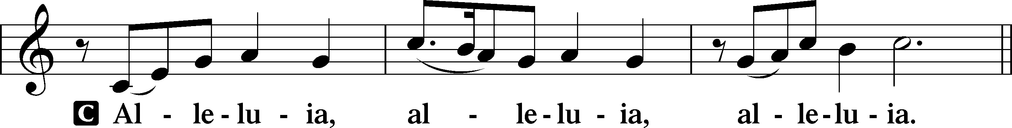

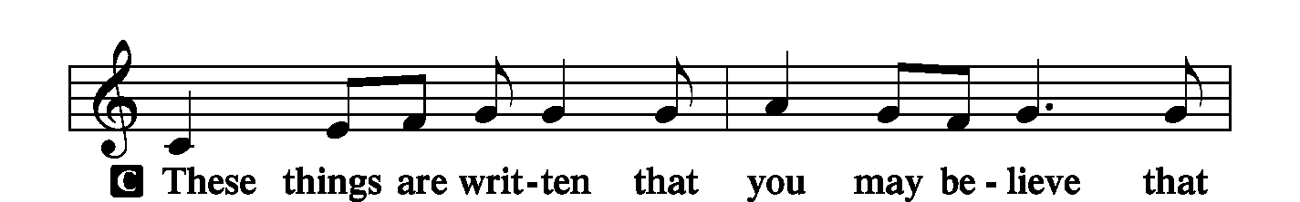
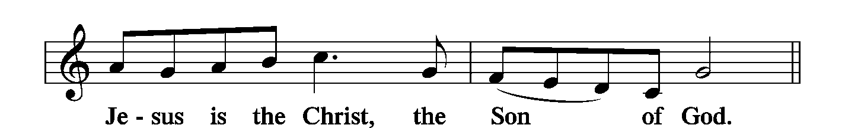
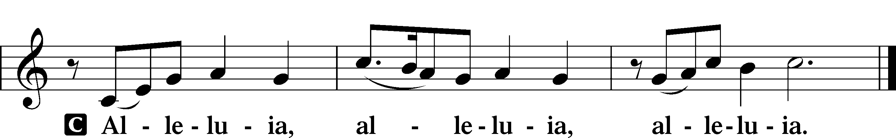

HOLY GOSPEL John 10:22–30
P The Holy Gospel according to St. John, the tenth chapter.
C Glory to You, O Lord.

²²At that time the Feast of Dedication took place at Jerusalem. It was winter, ²³and Jesus was walking in the temple, in the colonnade of Solomon. ²⁴So the Jews gathered around him and said to him, “How long will you keep us in suspense? If you are the Christ, tell us plainly.” ²⁵Jesus answered them, “I told you, and you do not believe. The works that I do in my Father’s name bear witness about me, ²⁶but you do not believe because you are not part of my flock. ²⁷My sheep hear my voice, and I know them, and they follow me. ²⁸I give them eternal life, and they will never perish, and no one will snatch them out of my hand. ²⁹My Father, who has given them to me, is greater than all, and no one is able to snatch them out of the Father’s hand. ³⁰I and the Father are one.”

P This is the Gospel of the Lord.
C Praise to You, O Christ.

NICENE CREED
C I believe in one God,
the Father Almighty,
maker of heaven and earth
and of all things visible and invisible.
And in one Lord Jesus Christ,
the only-begotten Son of God,
begotten of His Father before all worlds,
God of God, Light of Light,
very God of very God,
begotten, not made,
being of one substance with the Father,
by whom all things were made;
who for us men and for our salvation came down from heaven
and was incarnate by the Holy Spirit of the virgin Mary
and was made man;
and was crucified also for us under Pontius Pilate.
He suffered and was buried.
And the third day He rose again according to the Scriptures
and ascended into heaven
and sits at the right hand of the Father.
And He will come again with glory to judge both the living and the dead,
whose kingdom will have no end.
And I believe in the Holy Spirit,
the Lord and giver of life,
who proceeds from the Father and the Son,
who with the Father and the Son together is worshiped and glorified,
who spoke by the prophets.
And I believe in one holy Christian and apostolic Church,
I acknowledge one Baptism for the remission of sins,
and I look for the resurrection of the dead
and the life T of the world to come. Amen.

Please be seated

“ALL GOD’S CHILDREN” TALK
SERMON HYMN
The Lord’s My Shepherd, I’ll Not Want LSB 710
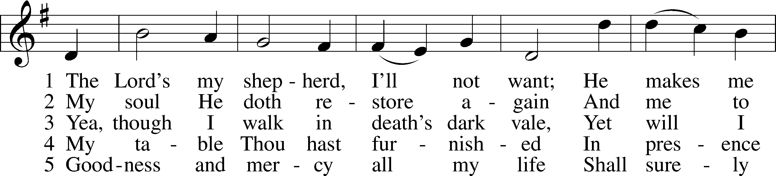
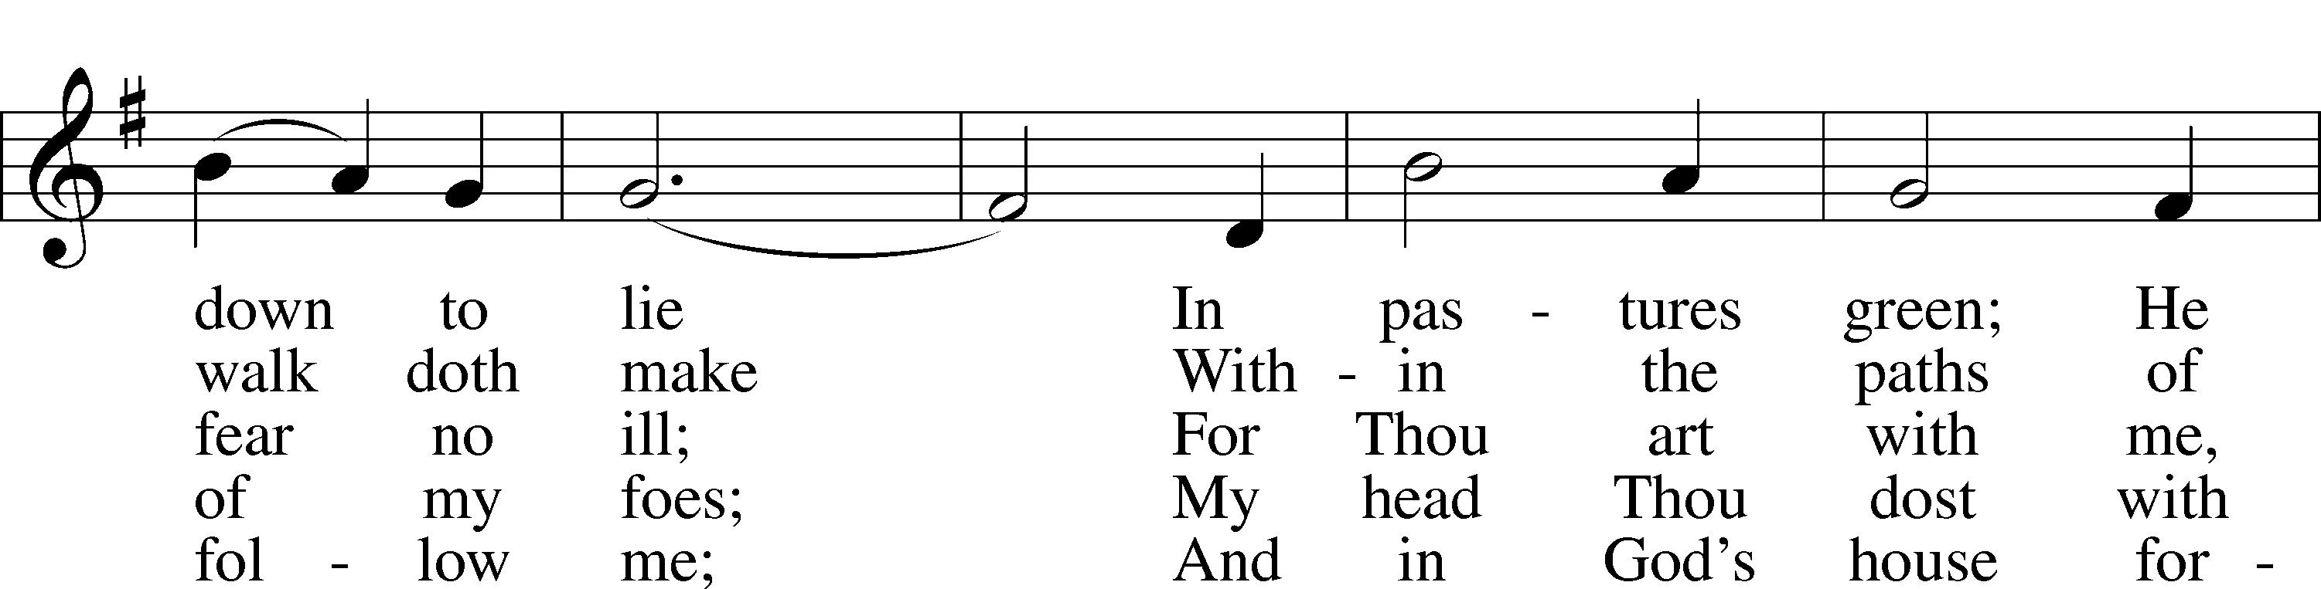
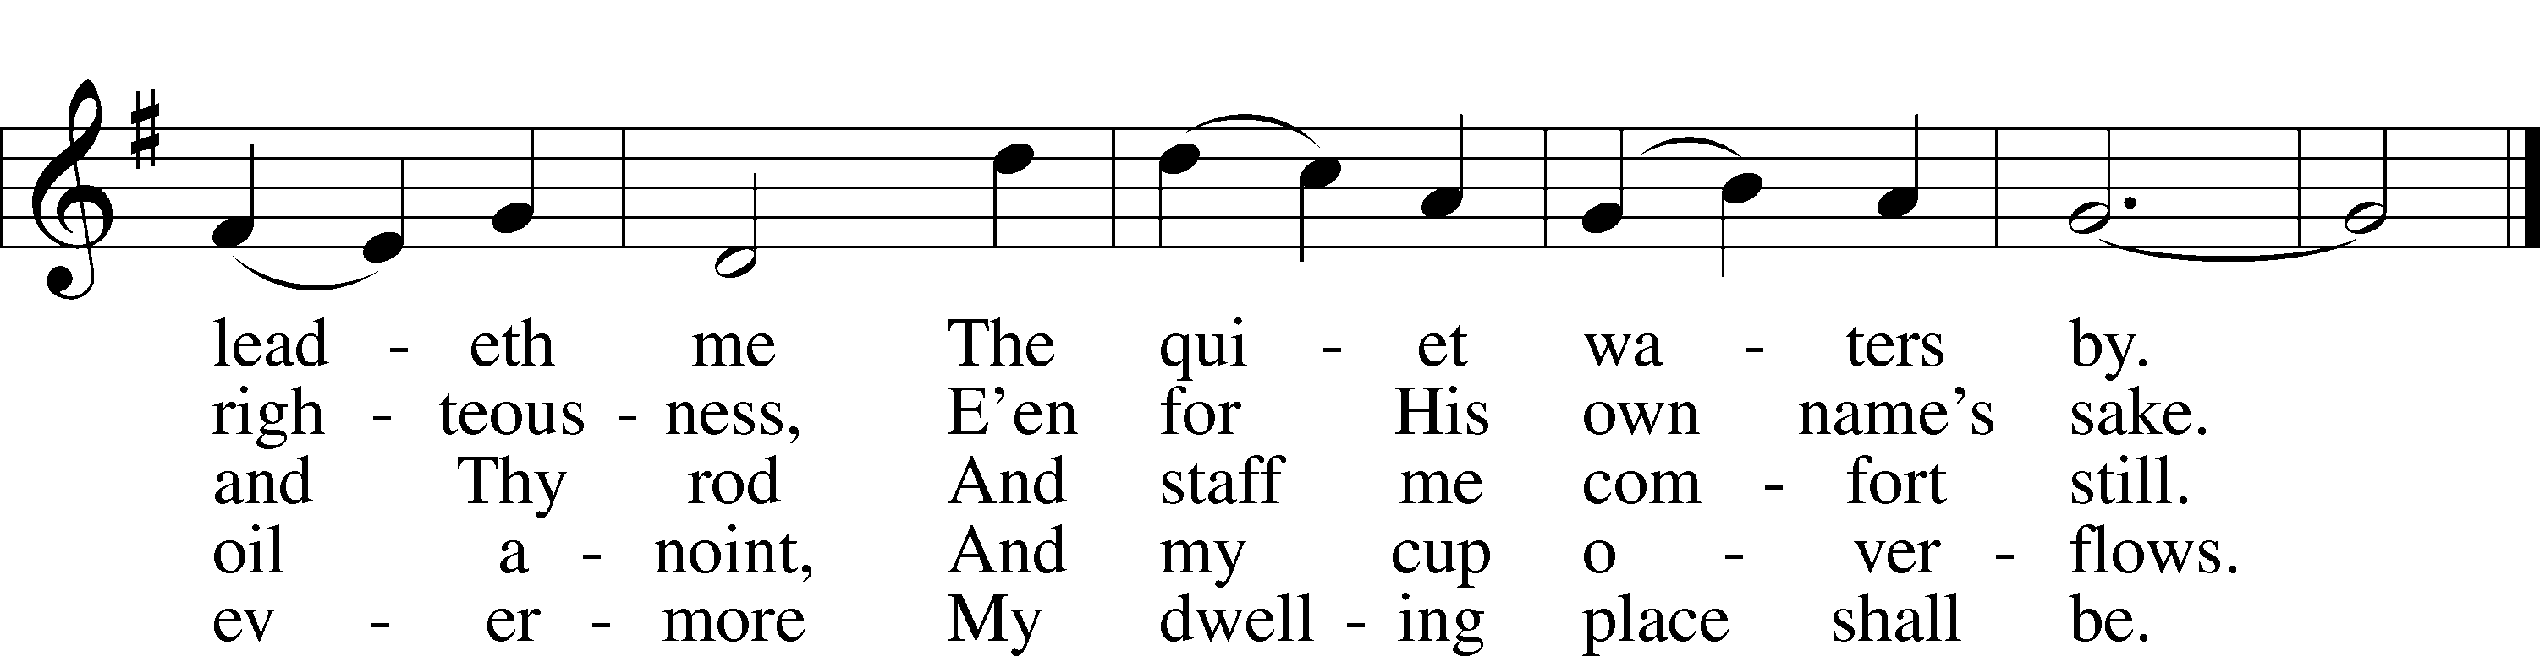
SERMON
Please stand as able

PRAYER of the CHURCH
After each Segment:
P Lord, in Your Mercy,
C Hear our Prayer.
After Final Segment:
P Hear us as we pray in His name and as He has taught us:

LORD’S PRAYER
C Our Father who art in heaven,
hallowed be Thy name,
Thy kingdom come,
Thy will be done on earth
as it is in heaven;
give us this day our daily bread;
and forgive us our trespasses
as we forgive those
who trespass against us;
and lead us not into temptation,
but deliver us from evil.
For Thine is the kingdom
and the power and the glory
forever and ever. Amen.

SERVICE of the SACRAMENT

PREFACE LSB 208
P The Lord be with you.
C And also with you.
P Lift up your hearts.
C We lift them to the Lord.

P Let us give thanks to the Lord our God.
C It is right to give Him thanks and praise.

P It is truly good, right, and salutary that we should at all times and in all places give thanks to You, O Lord, holy Father, almighty and everlasting God, for the countless blessings You
so freely bestow on us and all creation. Above all, we give thanks for Your boundless love shown to us when You sent Your only-begotten Son, Jesus Christ, into our flesh and laid on Him our sin, giving Him into death that we might not die eternally. Because He is now risen from the dead and lives and reigns to all eternity, all who believe in Him will overcome sin and death and will rise again to new life. Therefore with angels and archangels and with all the company of heaven we laud and magnify Your glorious name, evermore praising You and singing;

SANCTUS LSB 208
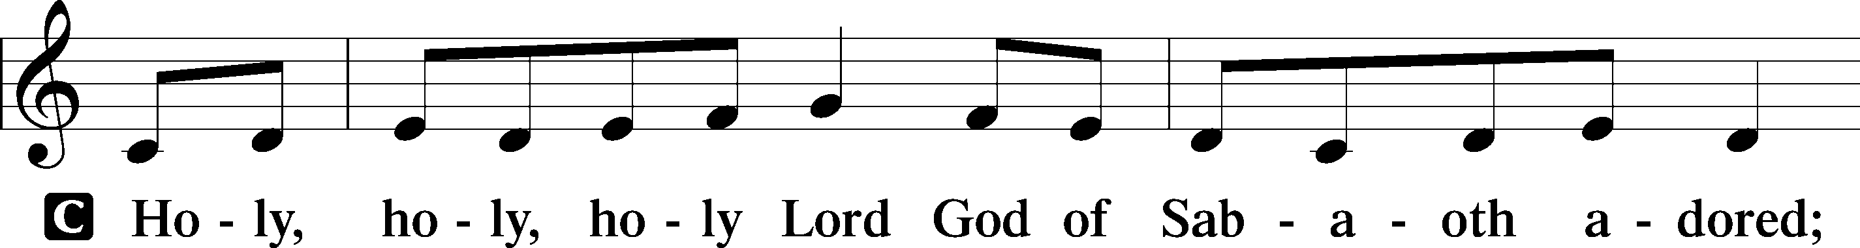
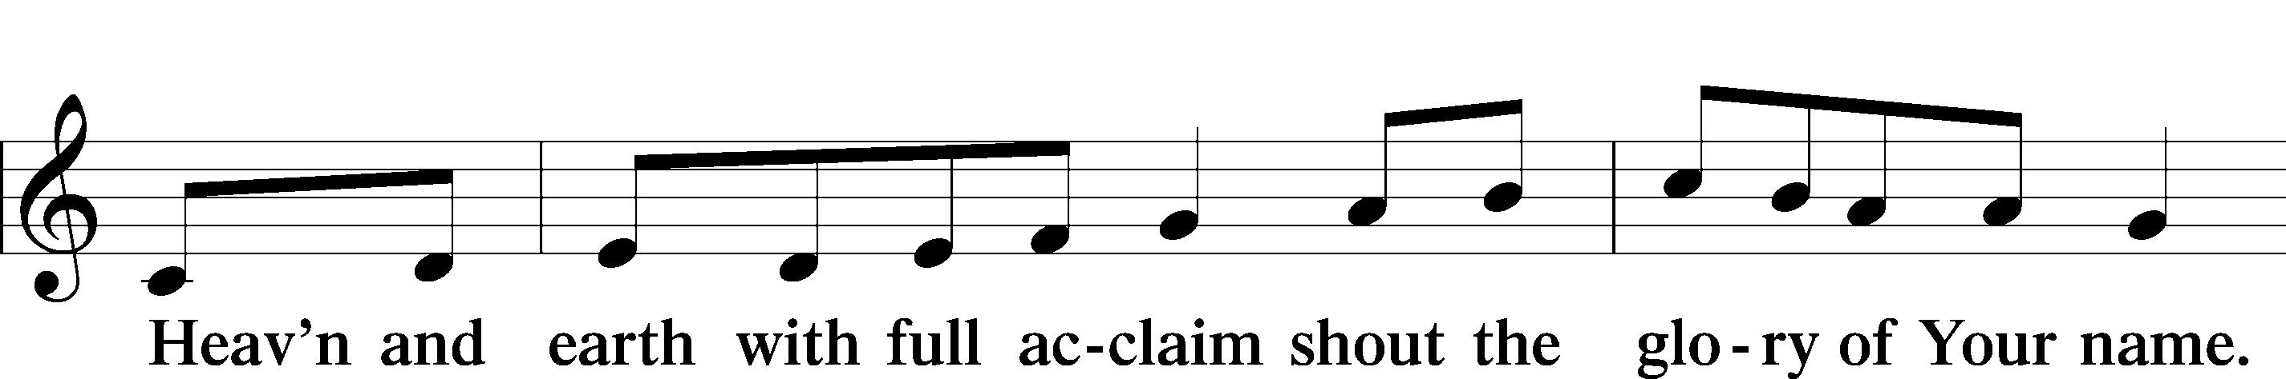
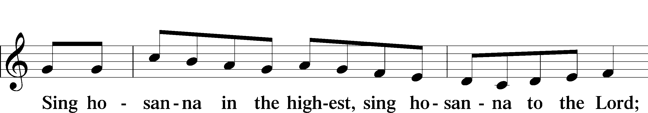

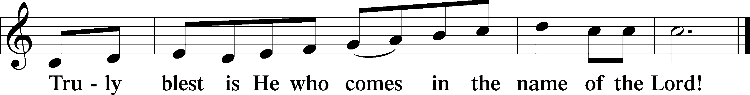

THE WORDS OF OUR LORD
P Our Lord Jesus Christ, on the night when He was betrayed, took bread, and when He had given thanks, He broke it and gave it to the disciples and said: “Take, eat; this is My T body, which is given for you. This do in remembrance of Me.”
In the same way also, He took the cup after supper, and when He had given thanks, He gave it to them, saying: “Drink of it, all of you; this cup is the New Testament in My T blood, which is shed for you for the forgiveness of sins. This do, as often as you drink it, in remembrance of Me.”
PAX DOMINI
P The peace of the Lord be with you always.
C Amen.
AGNUS DEI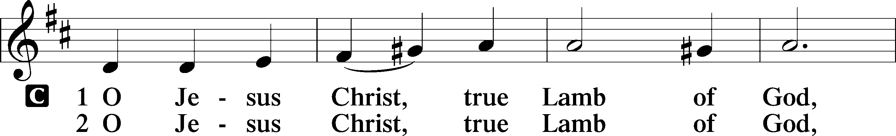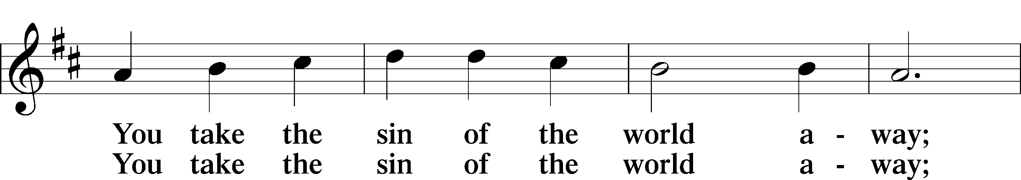
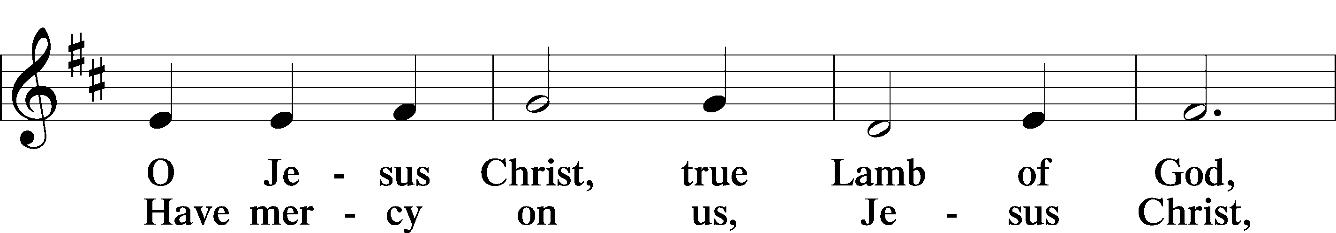
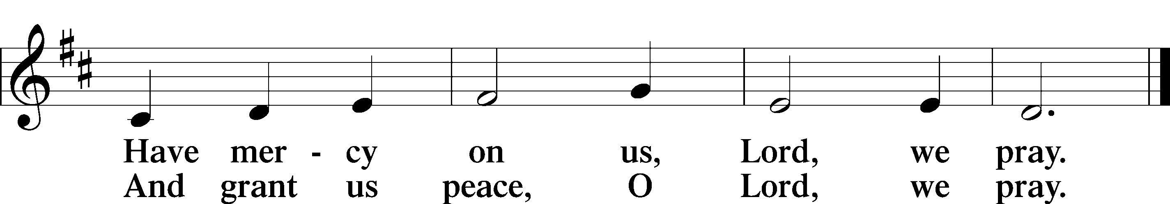

Please be seated

DISTRIBUTION
The pastor and those who assist him receive the body and blood of Christ first, then Communion will be served at the rail.. Ushers will help direct you forward via the center aisle; please return to your seats via the side aisles. Gluten-free bread is available for those who need it, as is non-alcoholic grape juice. Simply request either when you come forward to receive Communion.

DISTRIBUTION HYMN
I Am Trusting Thee, Lord Jesus LSB 729
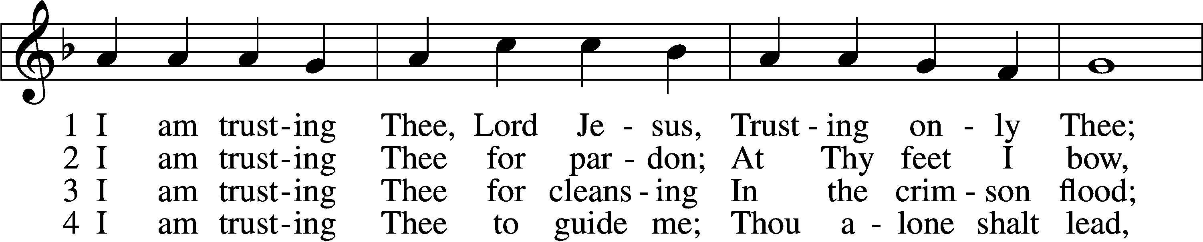
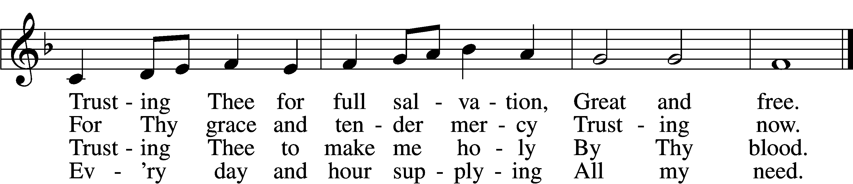

5 I am trusting Thee for power;
Thine can never fail.
Words which Thou Thyself shalt give me
Must prevail.

6 I am trusting Thee, Lord Jesus;
Never let me fall.
I am trusting Thee forever
And for all.
Text: Frances R. Havergal, 1836–79
Tune: Henry W. Baker, 1821–77
Text and tune: Public domain

Please stand as able

NUNC DIMITTIS LSB 211
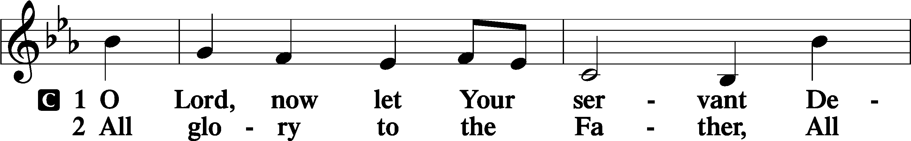
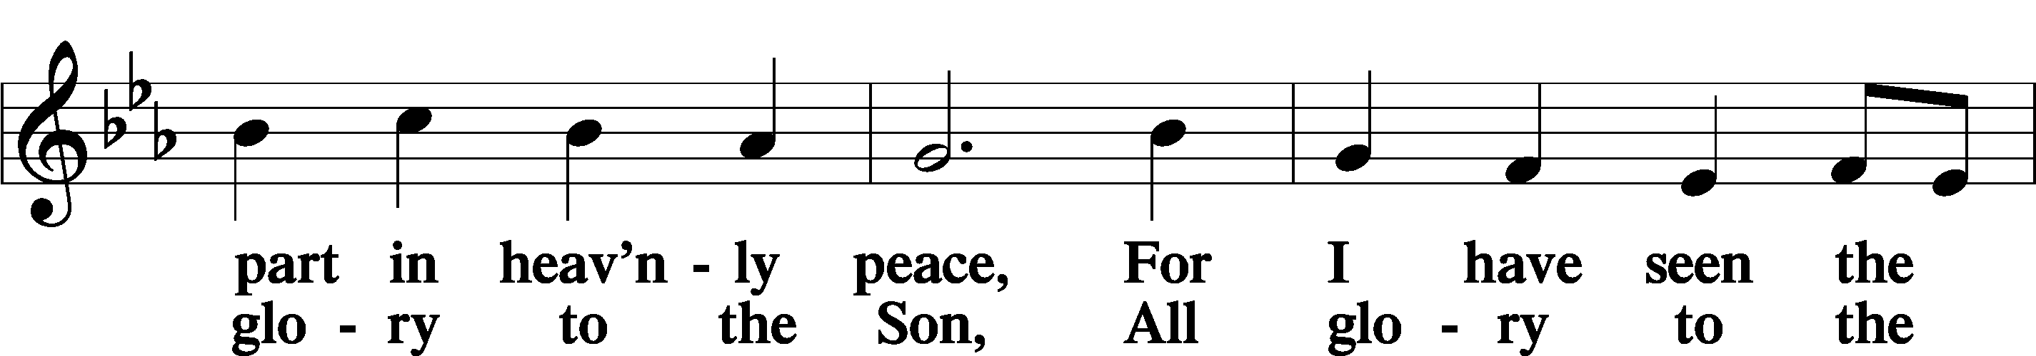
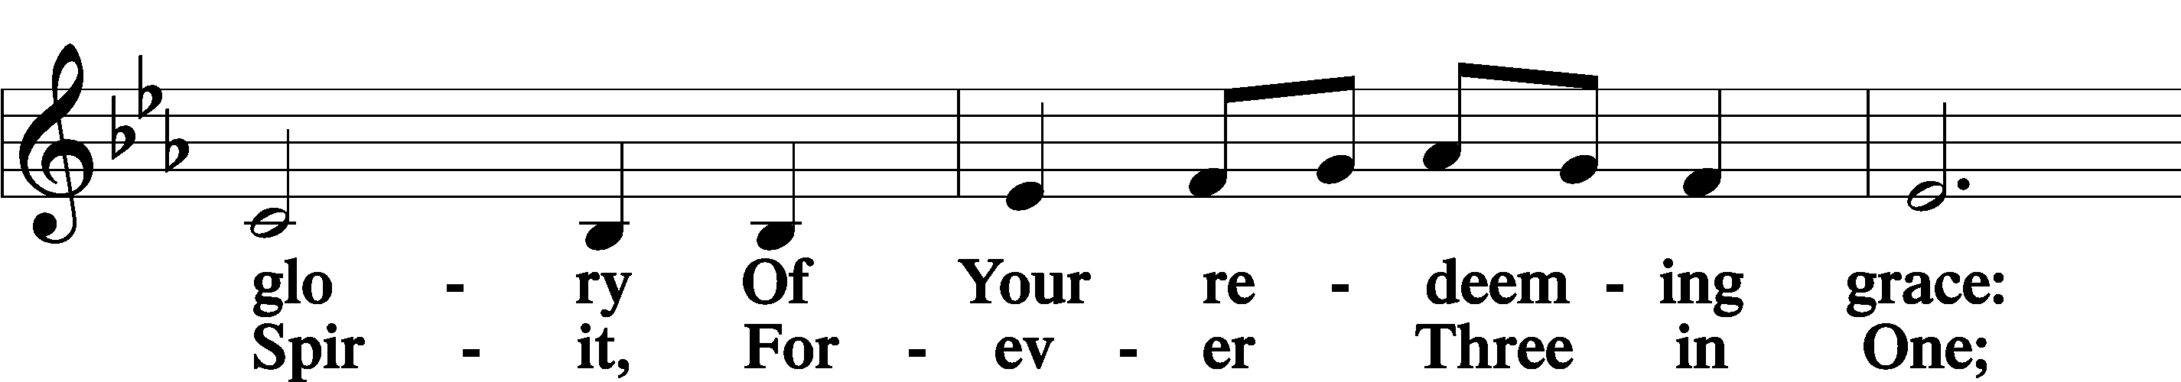
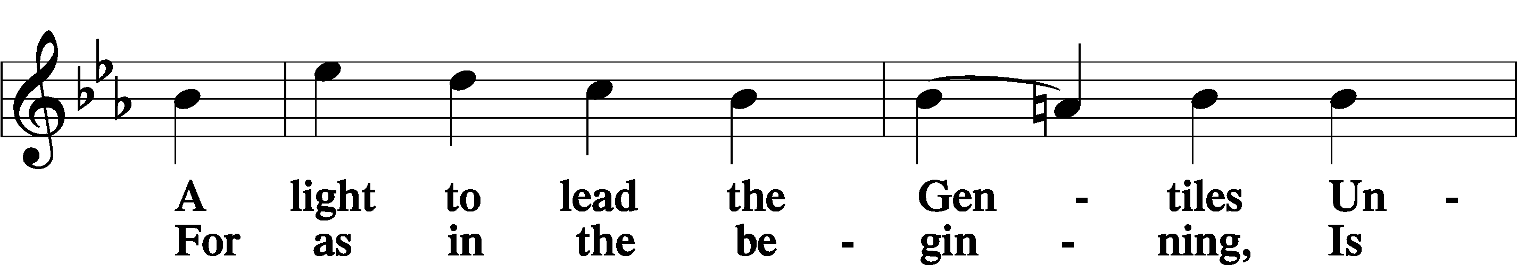
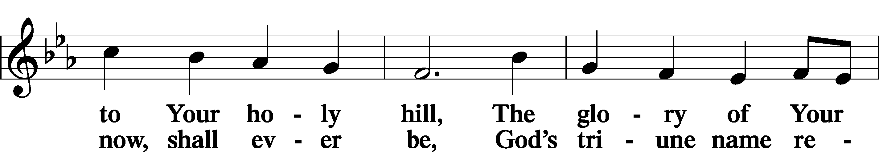
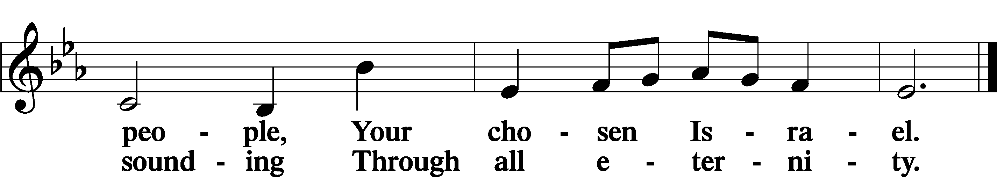

POST COMMUNION COLLECT
P Let us pray.
O God the Father, the fountain and source of all goodness, who in loving-kindness sent Your only-begotten Son into the flesh, we thank You that for His sake You have given us pardon and peace in this Sacrament, and we ask You not to forsake Your children but always to rule our hearts and minds by Your Holy Spirit that we may be enabled constantly to serve You; through Jesus Christ, Your Son, our Lord, who lives and reigns with You and the Holy Spirit, one God, now and forever.
C Amen.

BENEDICAMUS LSB 212
P Let us bless the Lord.
C Thanks be to God.
BENEDICTION
P The Lord bless you and keep you.
The Lord make His face shine on you and be gracious to you.
The Lord look upon you with favor and T give you peace.
C Amen.

Please be seated
CLOSING HYMN
Lord, Take My Hand and Lead Me LSB 722
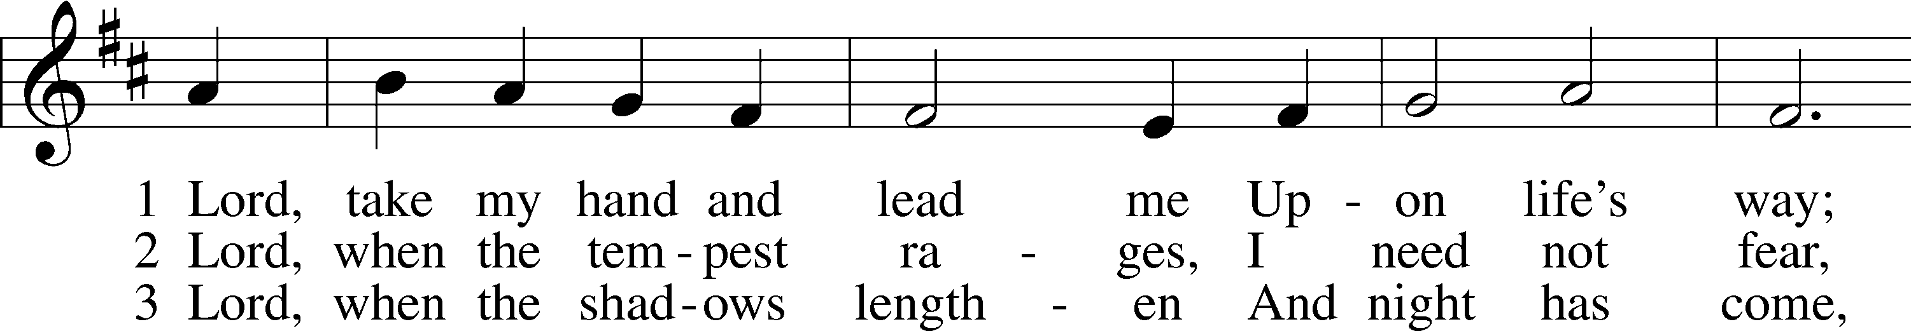
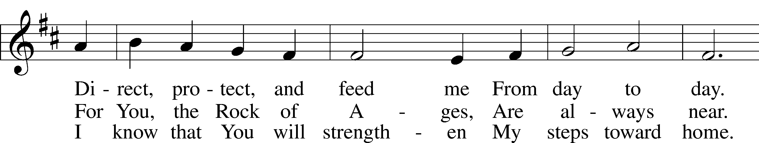
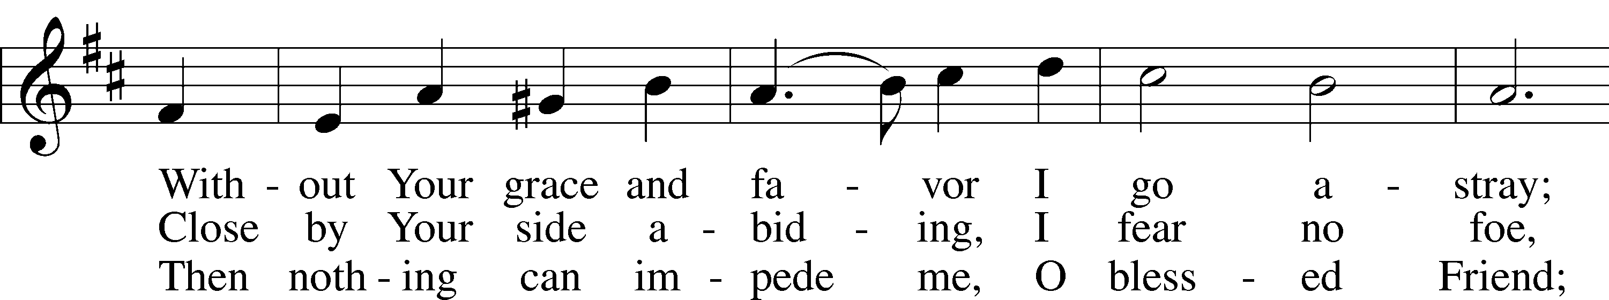
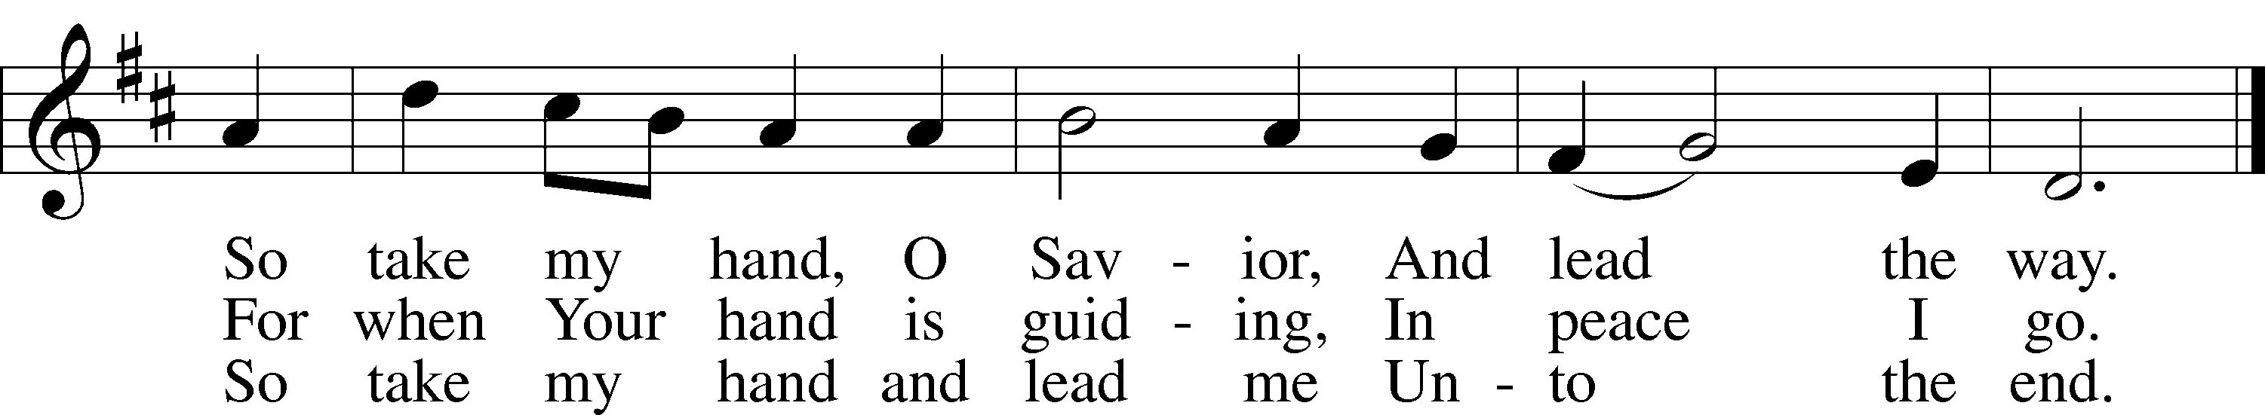
Text: Julie von Hausmann, 1825–1901; tr. Lutheran Book of Worship, 1978, alt.
Tune: P. Friedrich Silcher, 1789–1860
Text: © 1978 Lutheran Book of Worship. Used by permission: LSB Hymn License no. 110002537
Tune: Public domain

ANNOUNCEMENTS and SENDING WORDS
P We go to live for Jesus!
C We go to share His love!

Acknowledgments
Unless otherwise indicated, Scripture quotations are from the ESV® Bible (The Holy Bible, English Standard Version®), copyright © 2001 by Crossway, a publishing ministry of Good News Publishers. Used by permission. All rights reserved. Created by Lutheran Service Builder© Concordia Publishing House.

NEXT WEEKS READINGS
Old Testament: Acts 11:1-18
Epistle: Revelation 21:1-7
Holy Gospel: John 16:12-22

SERVING in GODS HOUSE TODAY
Pastor: Rev. Ken Bernthal
Elder: Tim Arner
Ushers: Risa Sherman, Linda West
Greeters: Bob & Kathy Erat
Coffee: LWML
Counters: Donna Cottrell, Leslie Martin
Altar Care: Jeanine Boldrey
Organ/Piano: Tom & Jean Beach
Children’s Talk: Nancy Ely
PRAYERS
Please contact the office with updates to the prayer list. People will remain on the prayer list for 4 weeks before being removed. If they need to remain on the list, please keep Elaine informed and of any updates. This will help us to have a more accurate list. Thanks for your cooperation.

Those who continue to grieve the passing of loved ones, The Family of Karen Christoff
Those with upcoming surgery:
Those recovering from surgery: Ron Kwapis
Those with health concerns: Tiffany Amsdill, Laurie Breen, Hope Buchinger, Betsy Cook Kay Gregg, Hilda Koch, Jennifer Martin, Eleanor Raether, Beth Smith, Judi Stutzman, and Joann Whitney.
Those diagnosed with cancer: Leah Eicher, Maria Freimark, Rachel Frisch, Joe Gibson, Janice Knoellinger, Leslie Martin, Brian Morgan, Hope Osantowski,, Ken Radke, and John Stutzman.
Those under Hospice Home Care: Ruth Luebs, and Ken Williamson.
BIRTHDAYS: ANNIVERSARIES;
5/10 Rita French 5/14 Harold & Nina Armstrong
5/13 Karl Scheiterlein
5/16 Sharon Techel

MESSAGES

MEMBER & GUEST CARDS: If you have not filled out a member/guest card, please take the time to fill one out and place it in the plate behind the back pews in our sanctuary.

WEDNESDAY MORNING BIBLE STUDY, 10:00am in the fellowship hall with Pastor Ken Bernthal.

CANCER and FRIENDS SUPPORT GROUP: Will be meeting May 24th . We will be having a guest speaker Wanita Morrison from the Cheboygan Cancer Group.. Remember Cancer & Friends Support Group is not just for people going through treatment, or survivors, we are also here for caregiver, spouse, children, and friends. During those difficult times we can al use someone to talk to. If there is any subject you would like to discuss with me you call or text or at 989-350-4391. Hope you will join us.

OTSEGO COUNTY FOOD PANTRY:
TEFAP remember that there will be a food giveaway on May 17th at Otsego County United Way parking lot 116 E. First St. from 10am to 1pm.

LWML Celebrate Spring and fellowship with friends with a MYSTERY HOSTESS dinner, sponsored by LWML and the Outreach Committee. What is a Mystery Hostess dinner? We are having a meal at church. You get to choose a meal that you would like, but you don’t know who is preparing your meal until the evening of the event when you join your host/hostess and fellow diners for a delicious meal. There is a sign up sheet listing the various meals which are available. You pick the one you want and then be prepared to be surprised by your host/hostess. This will be happening Friday, May 13 at 6 PM. Everyone is invited. Each meal/table is limited to 6 persons, so you will have an intimate dining experience. Please sign up for your culinary choice.

KUT-UPS: Next meeting will be May 16th in the fellowship hall.

LWML SUMMER POP-UP CRAFT SALES: LWML plans to have occasional mini craft sales this summer. With short notice we will set up a few canopies in the front yard and offer our crafts for sale, with the profits designated for missions, both locally and throughout the world. Dates have yet to be determined. So, crafters, please get thinking about what handmade items you can prepare in advance for us to sell. We welcome and appreciate your donations.

OUTREACH-CRAFT DAY-CARD MAKING: Join us Saturday May 14th from noon to 4pm.This will be the start of our first card craft day. The cost is $10.00 you will have the choice of making 10 cards (you will be working with a card maker. We are limited to 20 people and there is a sign-up sheet in the narthex on the board, please join us for this fun day.
CHURCH CLEAN UP DAY Sunday Mar 22nd after church. We need as many people as we can get-the more hands the sooner we can get it done. Bring your gloves, rakes, wheel barrows, and be ready to work. We will be working inside and outside of the church. Lunch will be provided. There is a signup sheet posted on the board in the narthex.
ALTAR FLOWERS: There are still spots open for Altar flowers, if you have birthdays, anniversaries, new baby or in memory of someone, or just for something special like dressing up the Altar. The signup sheet is in the fellowship hall as you go in the door. Flowers are $30.00 for the two flowers. Order them, they will be put on the altar, and then take them home to enjoy.
LWML is electing a VP and Treasurer this year. We will have a quick election after church on May 15th. We would like all women to gather briefly in the library to vote. If you are interested in running for either position, please talk to Carla Elenz soon.

THIS WEEK AT TRINITY
May 8 Sunday
9:00 am Worship Service - Holy Communion – Rev. Ken Bernthal
Mother’s Day
10:00 am Fellowship & Coffee Hour
10:30 am Bible Study with Dr. Tom Beach (Tutoring Room)
May 9 Monday
7:00 pm Choir
May 10 Tuesday
6:30 pm Council Meeting
May 11 Wednesday
10:00 am Wednesday Morning Bible Study W/ Pastor Ken Bernthal
May 12 Thursday
1:00 pm Ladies Guild Meeting - Library
May 13 Friday
6:00 pm LWML Mystery Host Meal
May 14 Saturday
12:00 pm Craft Card making- Fellowship Hall
May 15 Sunday
9:00 am Worship Service - Holy Communion – Rev. Paul Schneider
10:00 am Fellowship & Coffee Hour
10:30 am Bible Study with Dr. Tom Beach (Tutoring Room)

